## Git Repo Init and Code Checkin

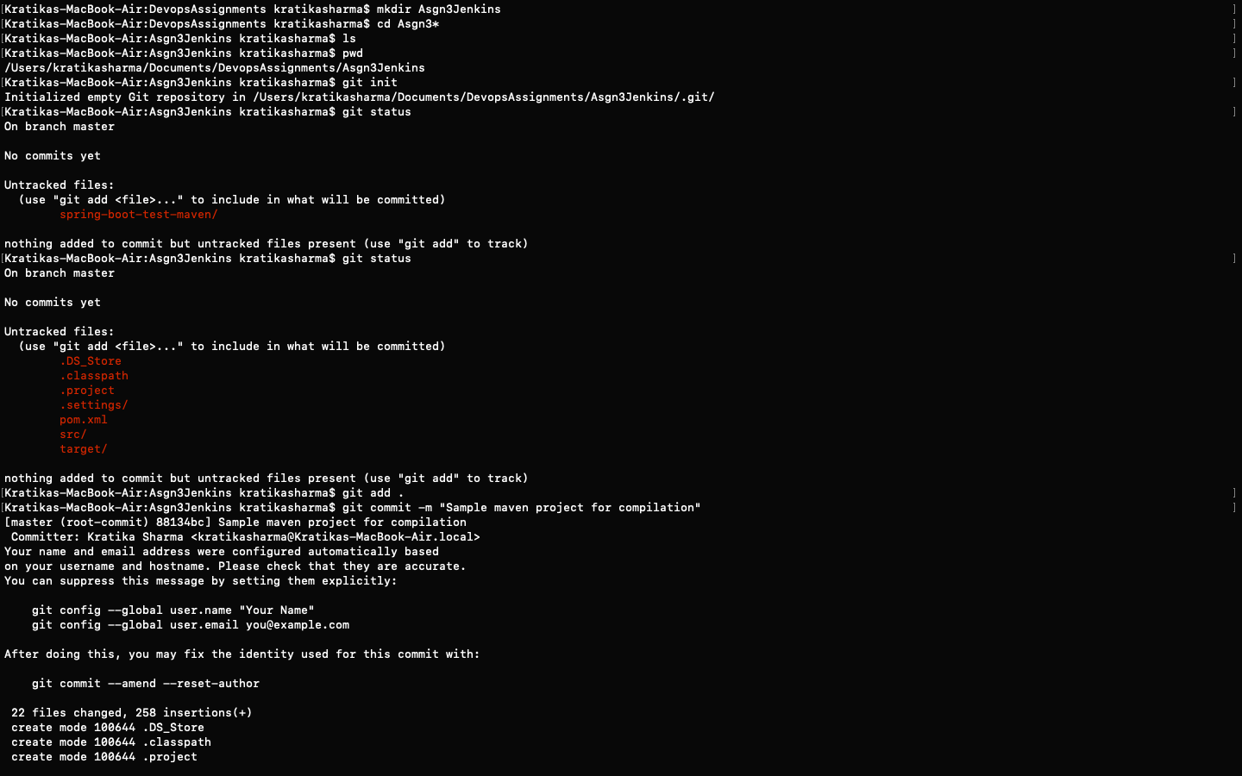

1. Created a new maven project

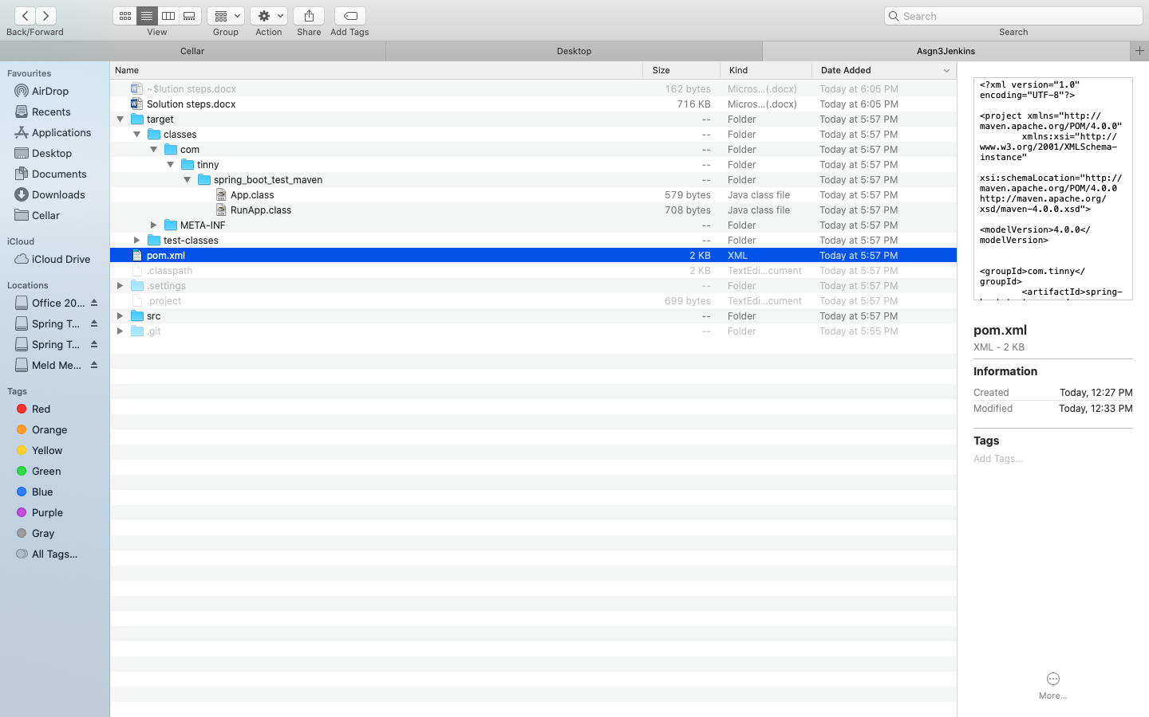

1. Added the maven project to remote repo

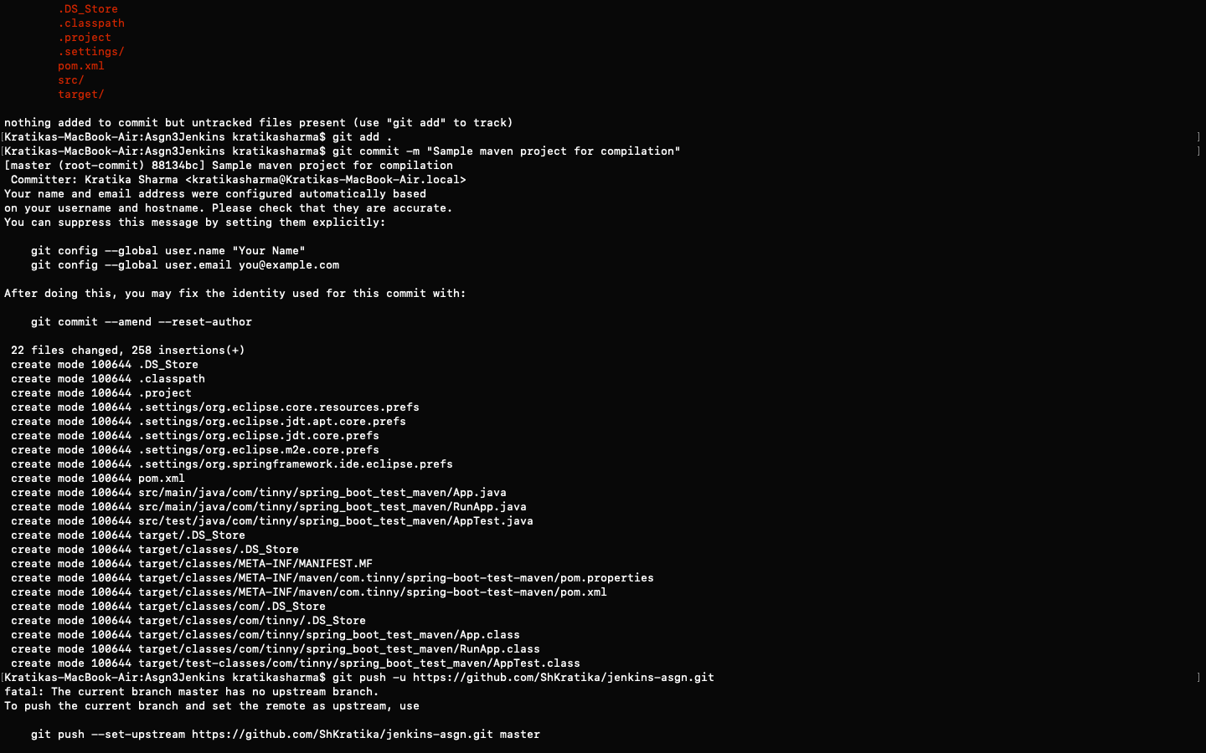

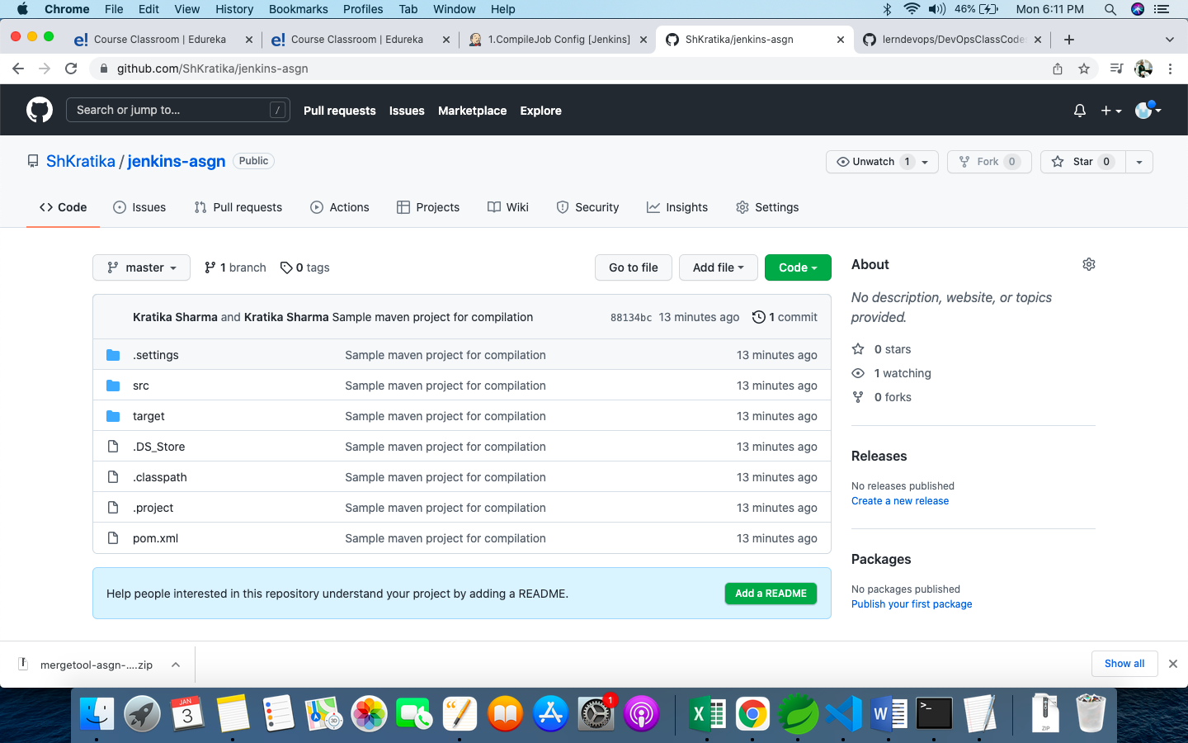

## **Compile job** in Jenkins pointing to the new remote repo:

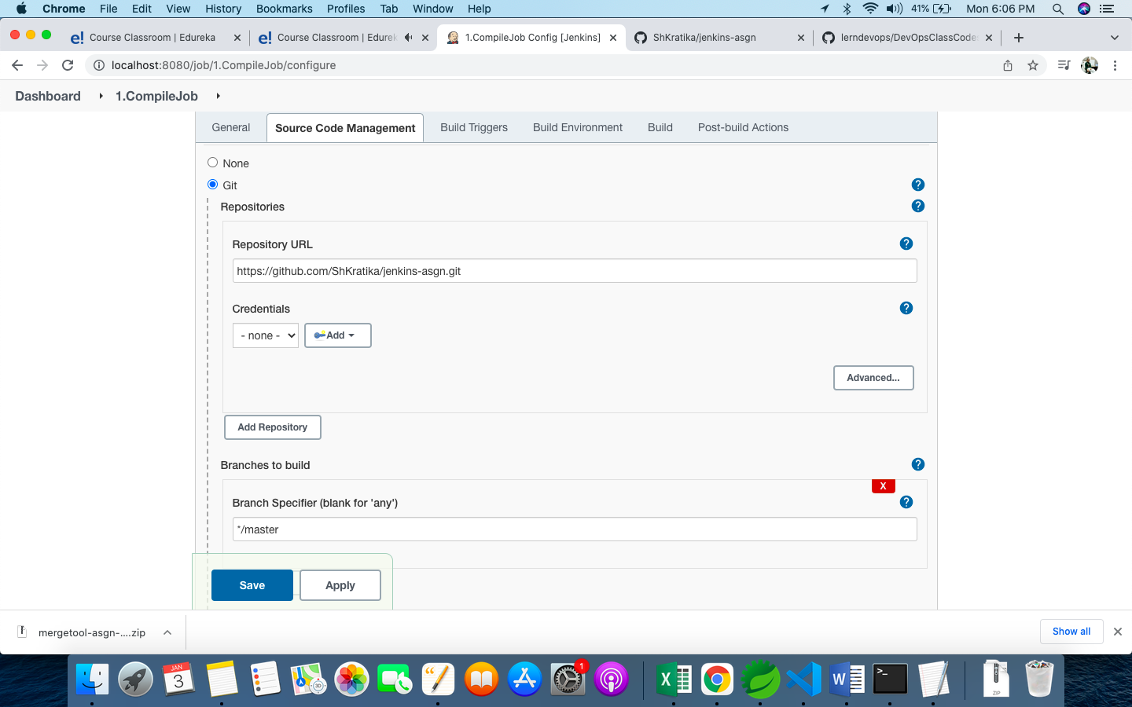

1. It polls SCM every minute to check changes to trigger new builds:

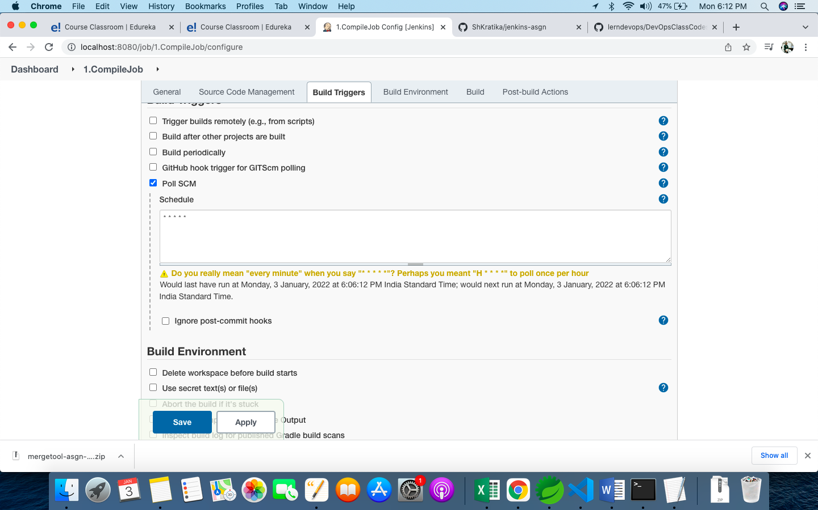

1. The build is successful:

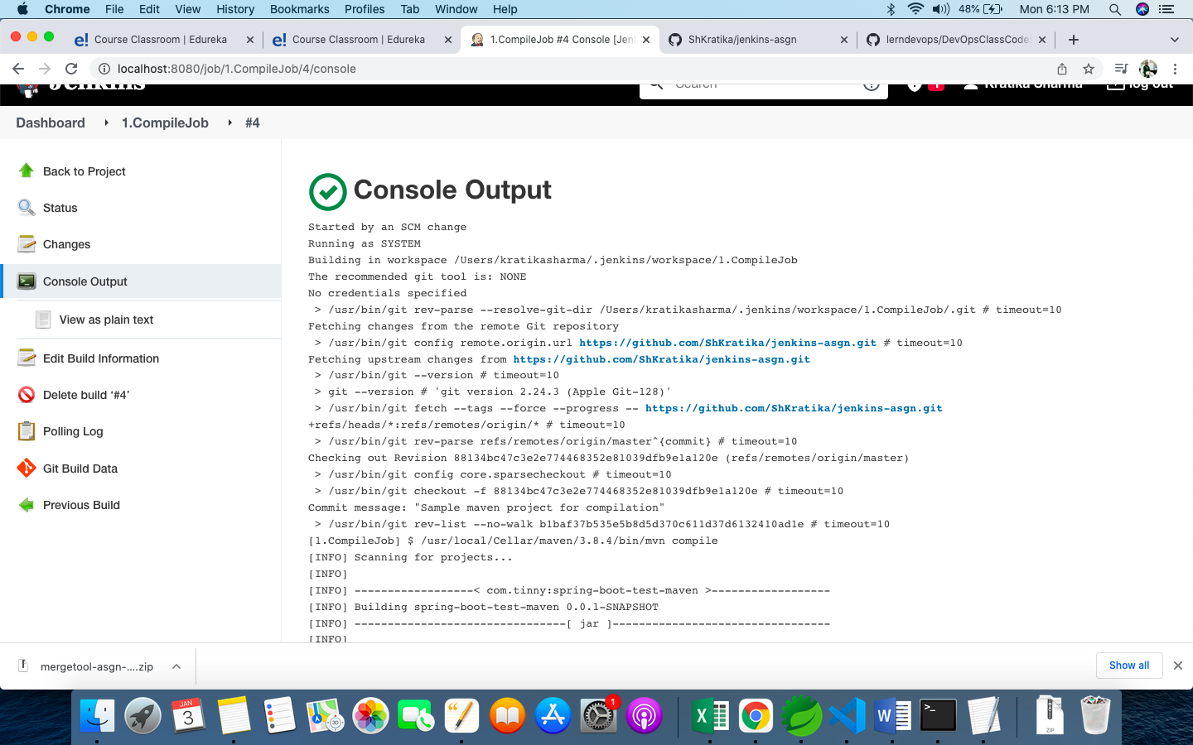

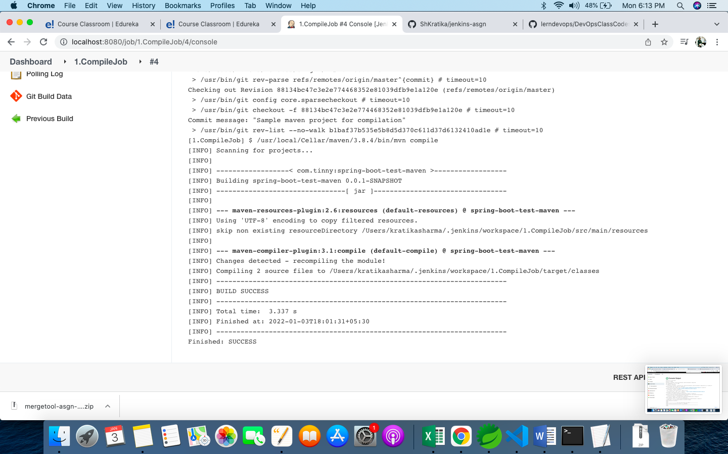

## **Code-Review Job**

1. Created a new job

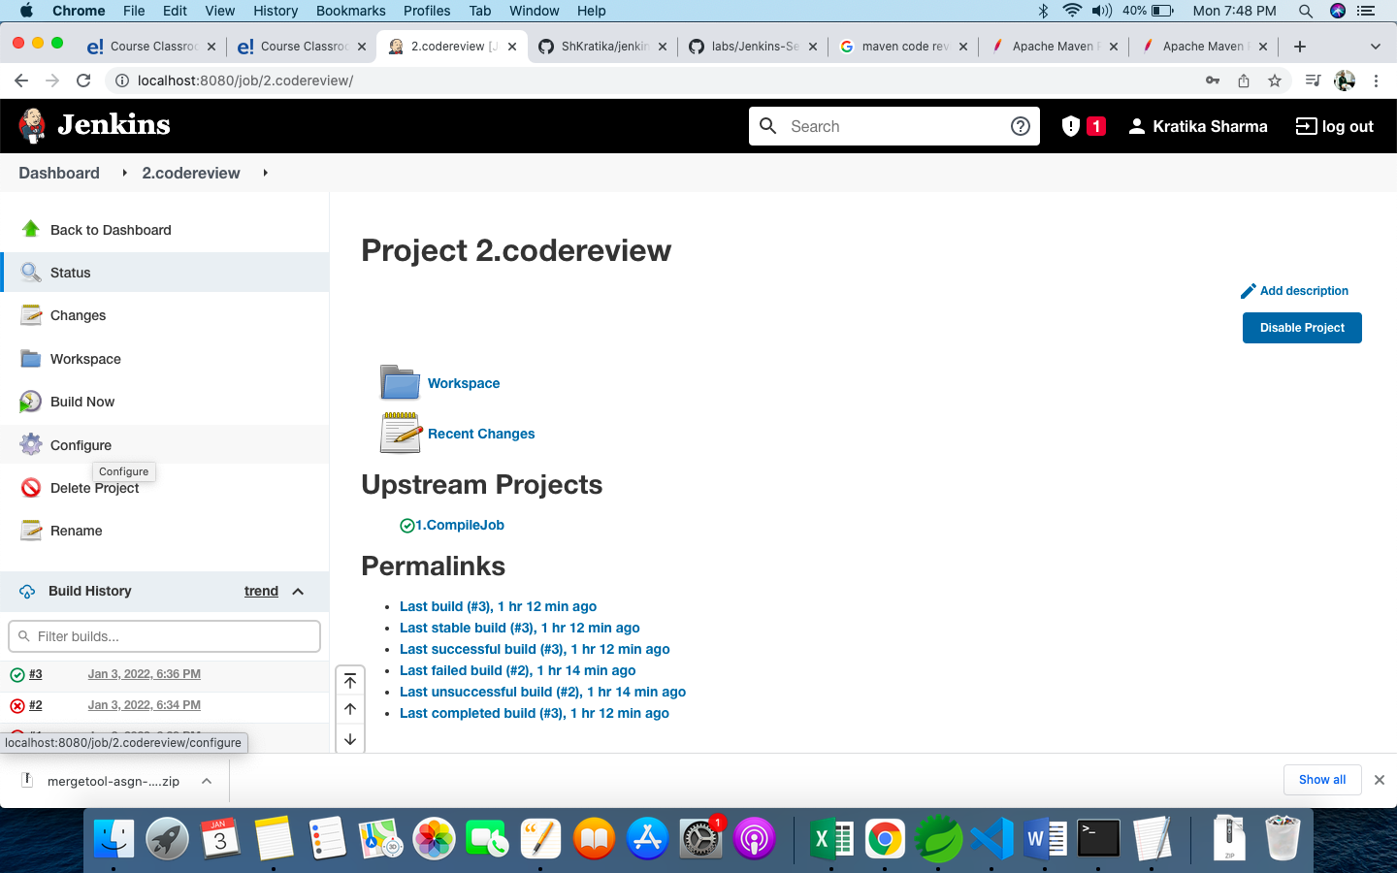

1. **Runs after Compile Job**

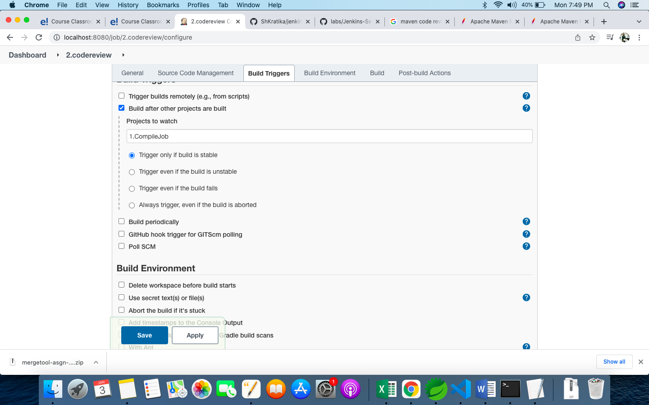

1. **Setup to build with pmd goal**

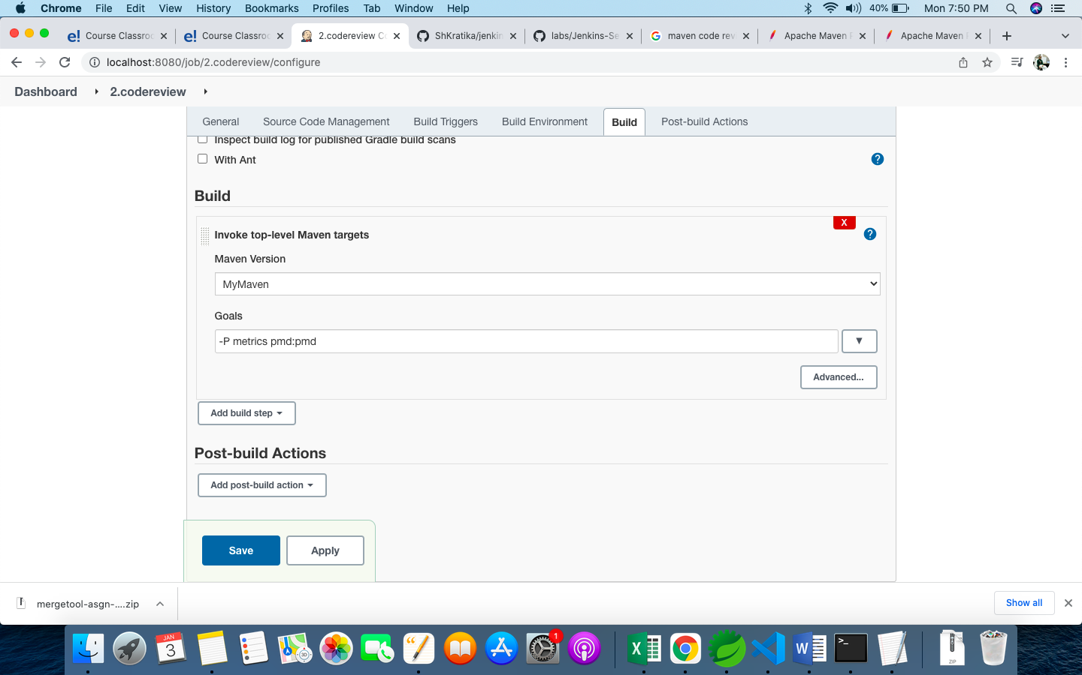

1. **Build successfully.**

## ../../../Desktop/Screenshot%202022-01-03%20at%207.42.44%20PM.png

## Unit Test Job

Configured to run after CodeReview Job on same git repo

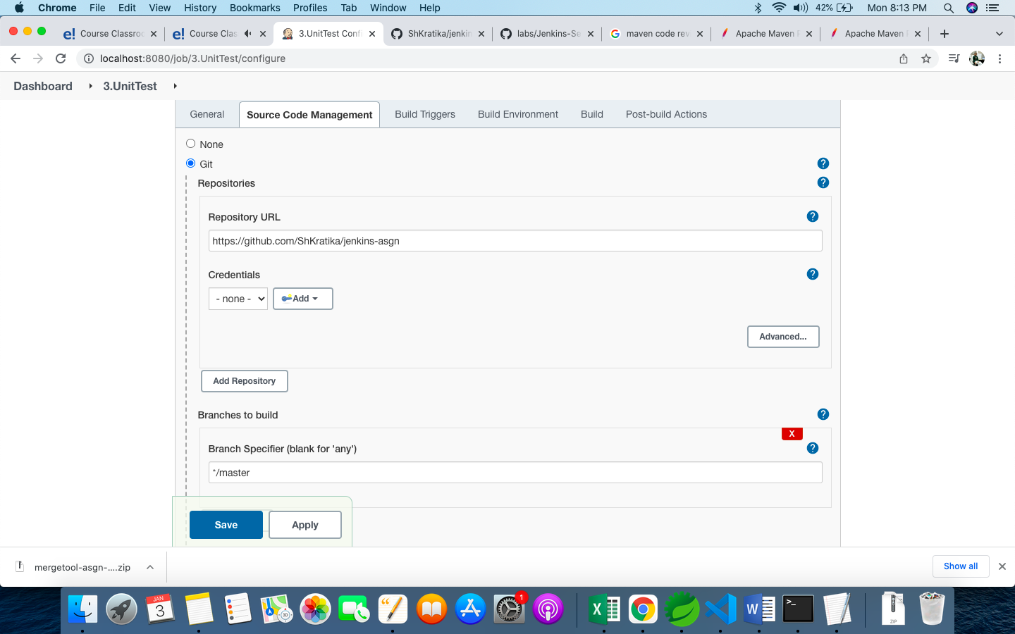

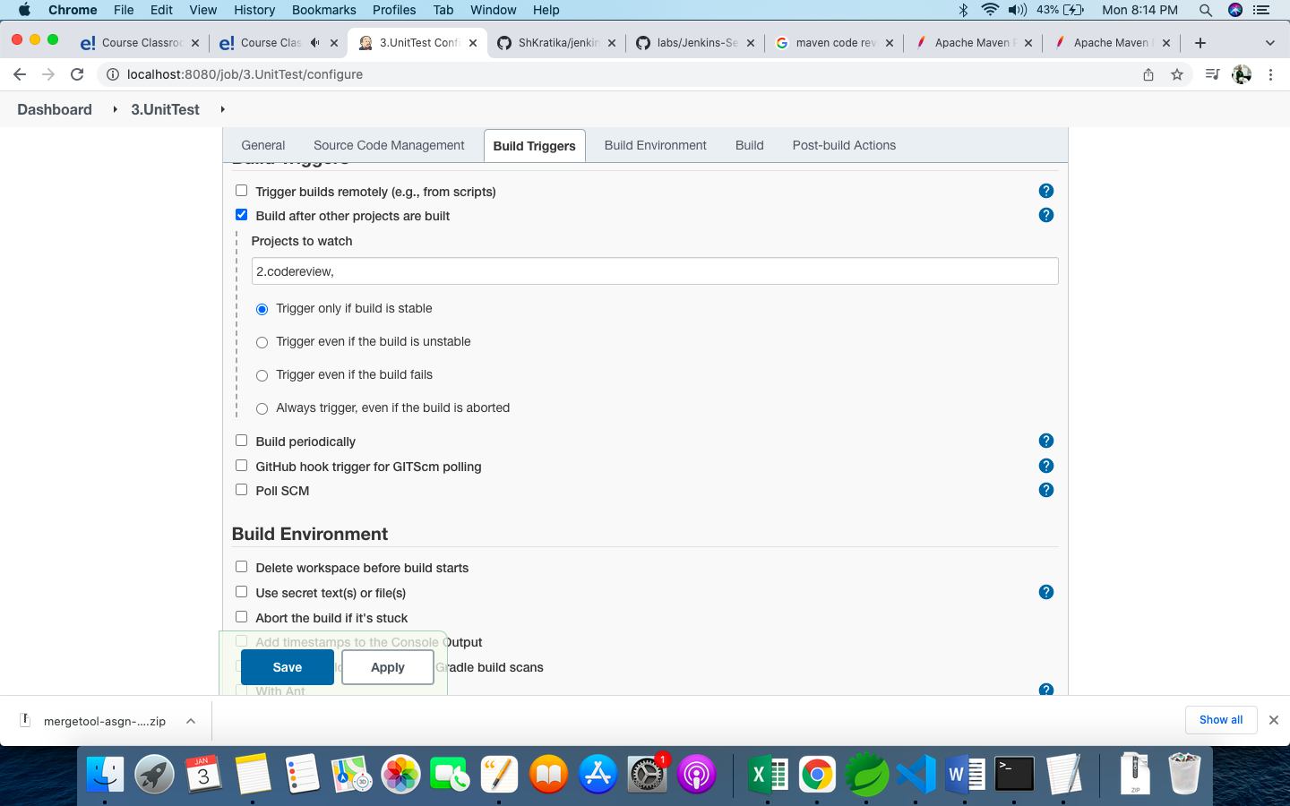

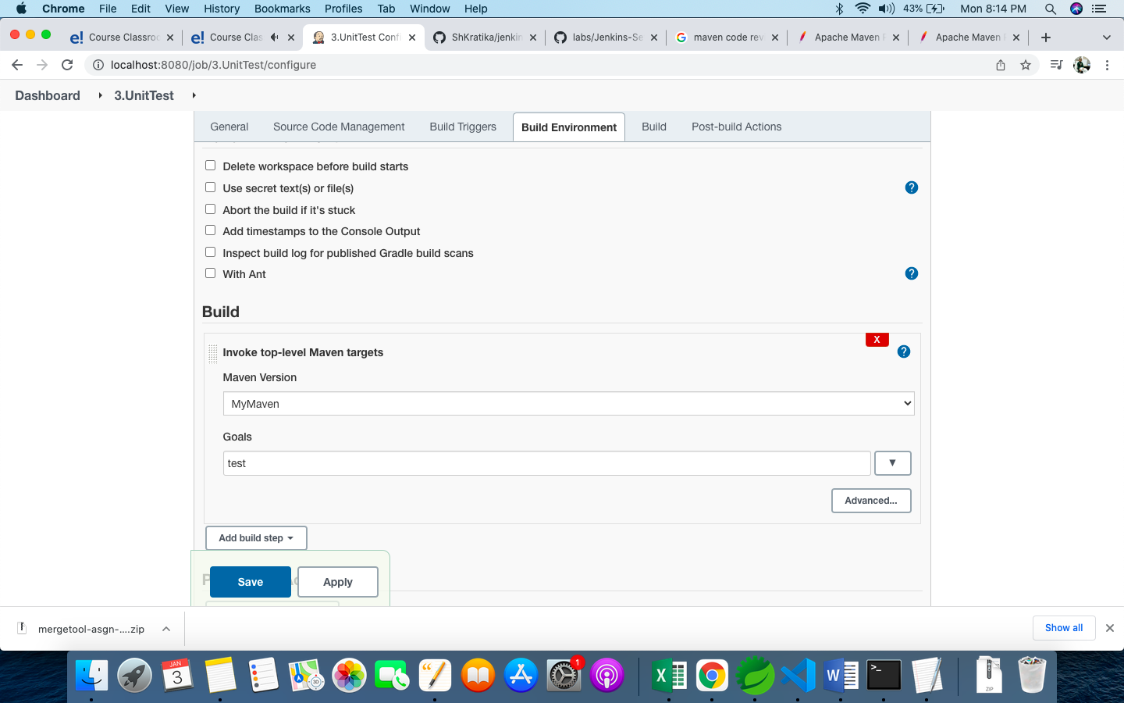

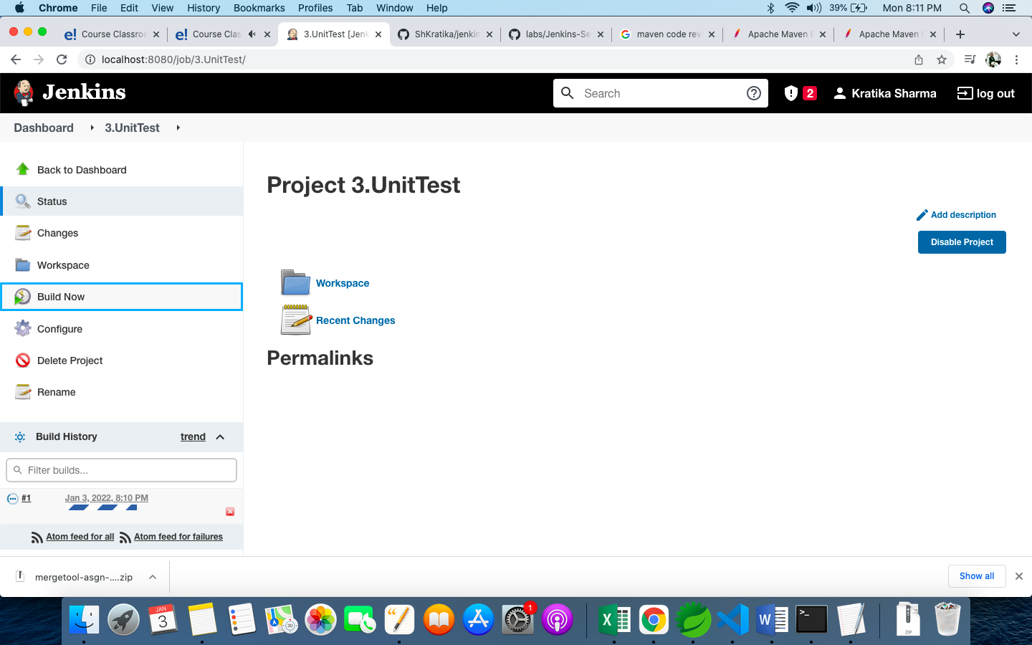

1. Build is successful.

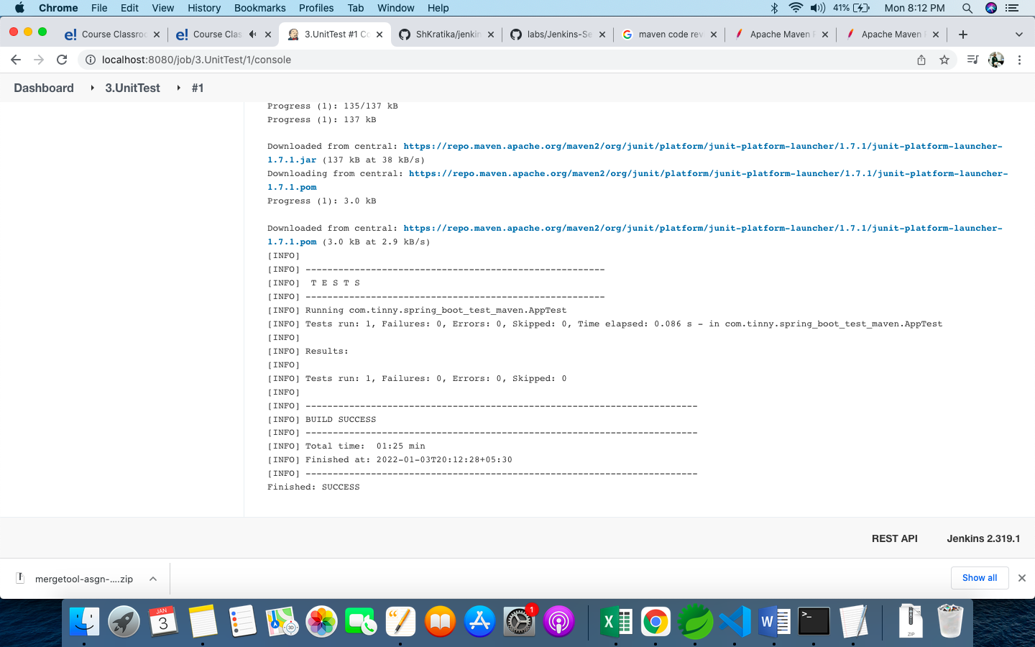

## Package Job

1. Initialized with same repo

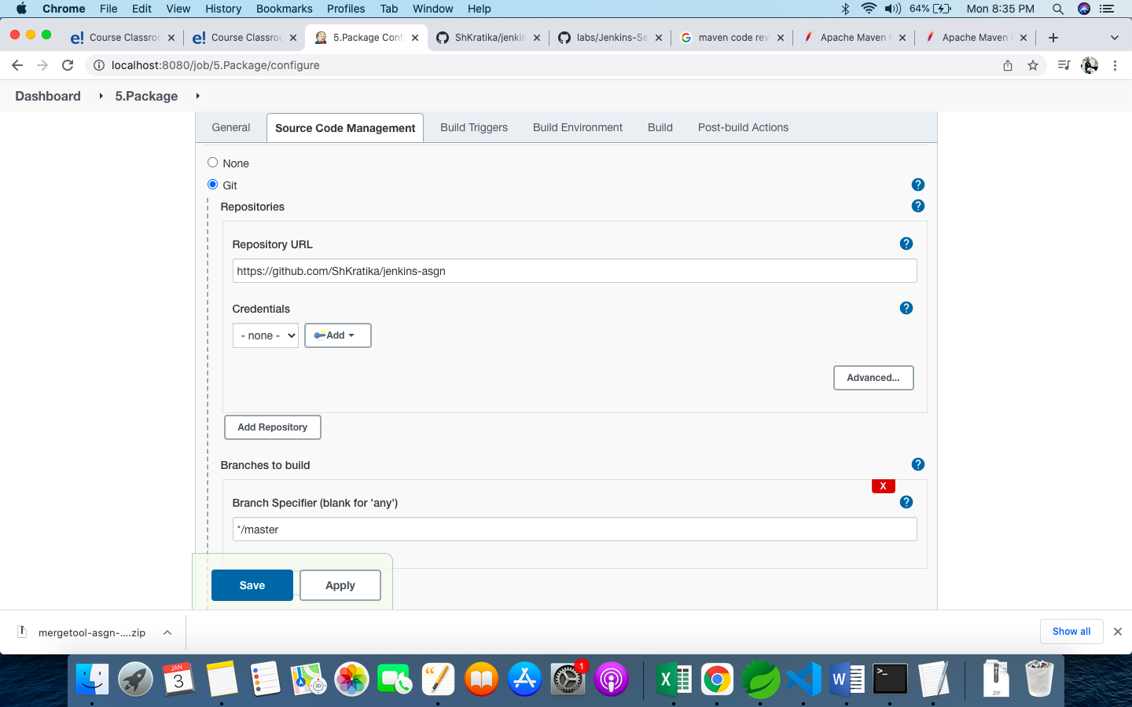

1. Runs after UnitTest build is complete

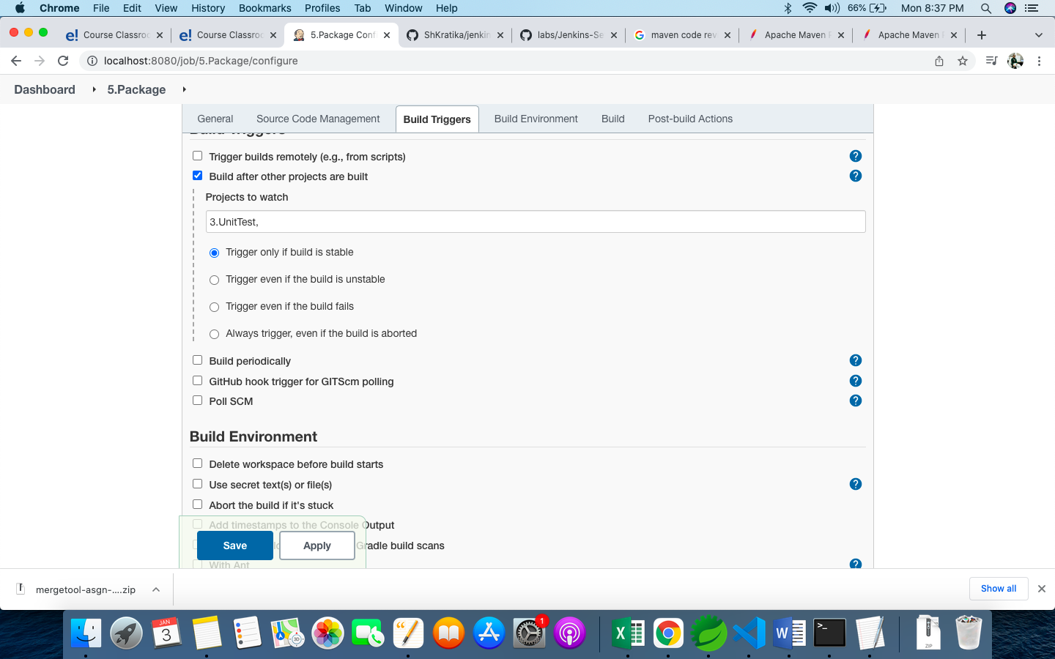

1. Build with package: goal

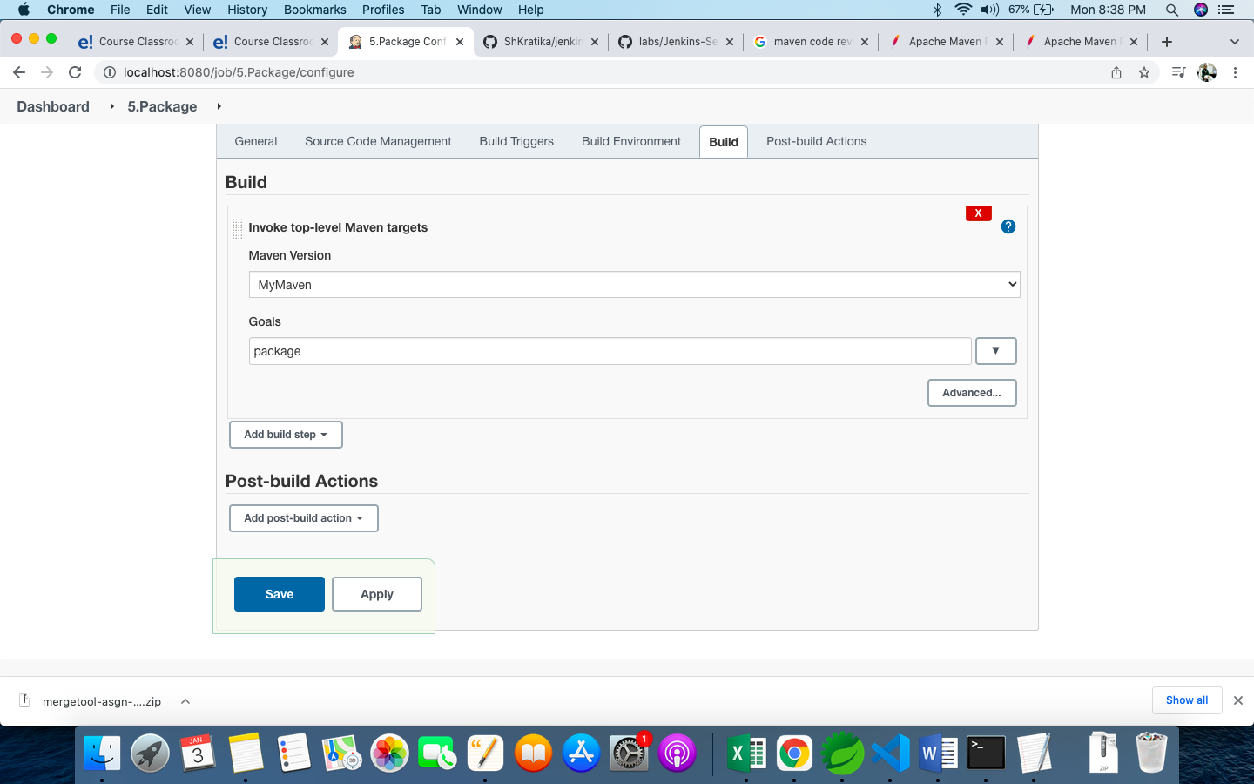

1. Build is successful and a jar is generated

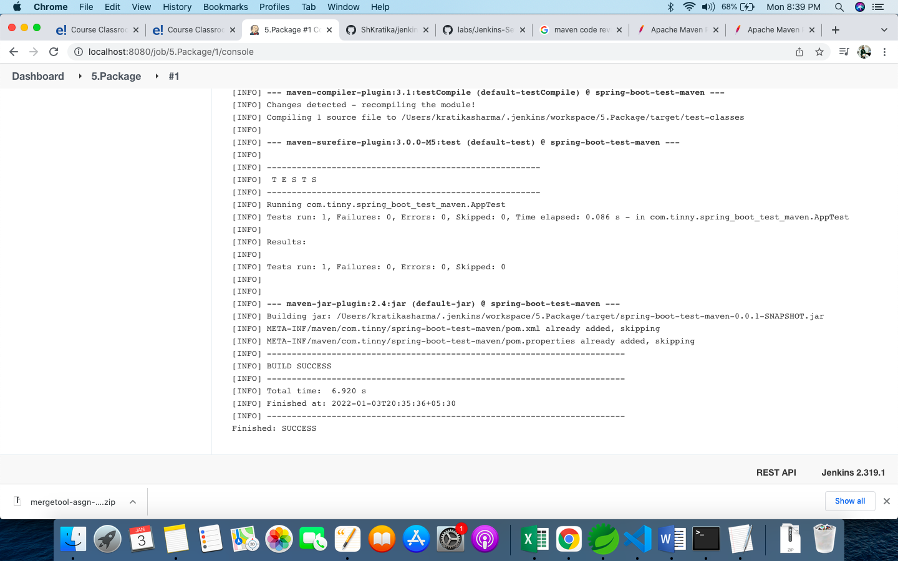

## Deploy Job

1. Starts and Builds after Package Job

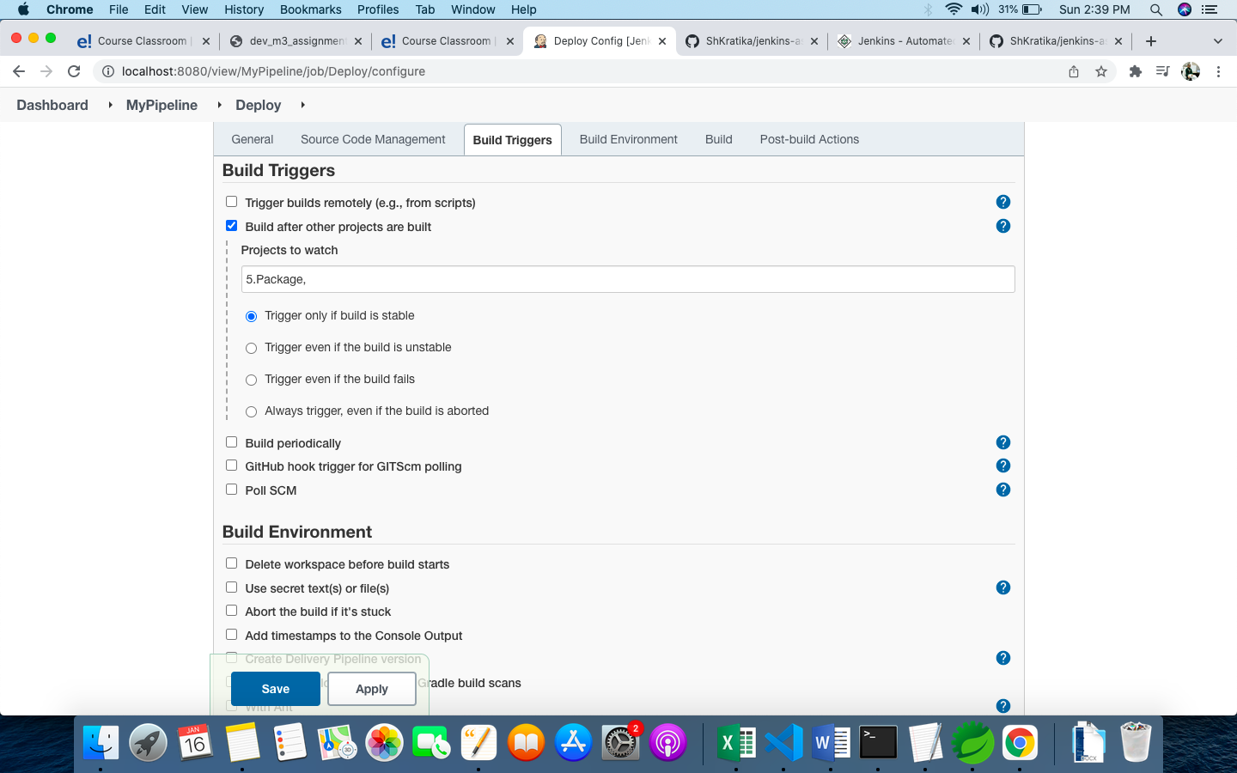

1. Copies above jar from Jenkins workspace to destination folder

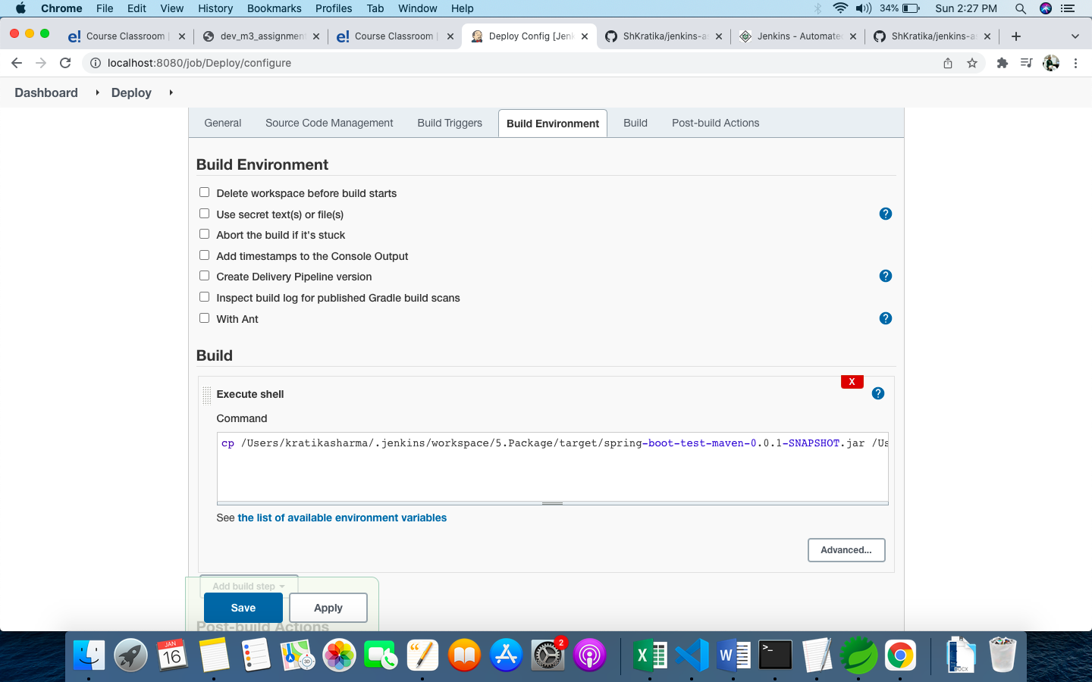

1. Pipeline Built Successfully in Jenkins with a change in SCM

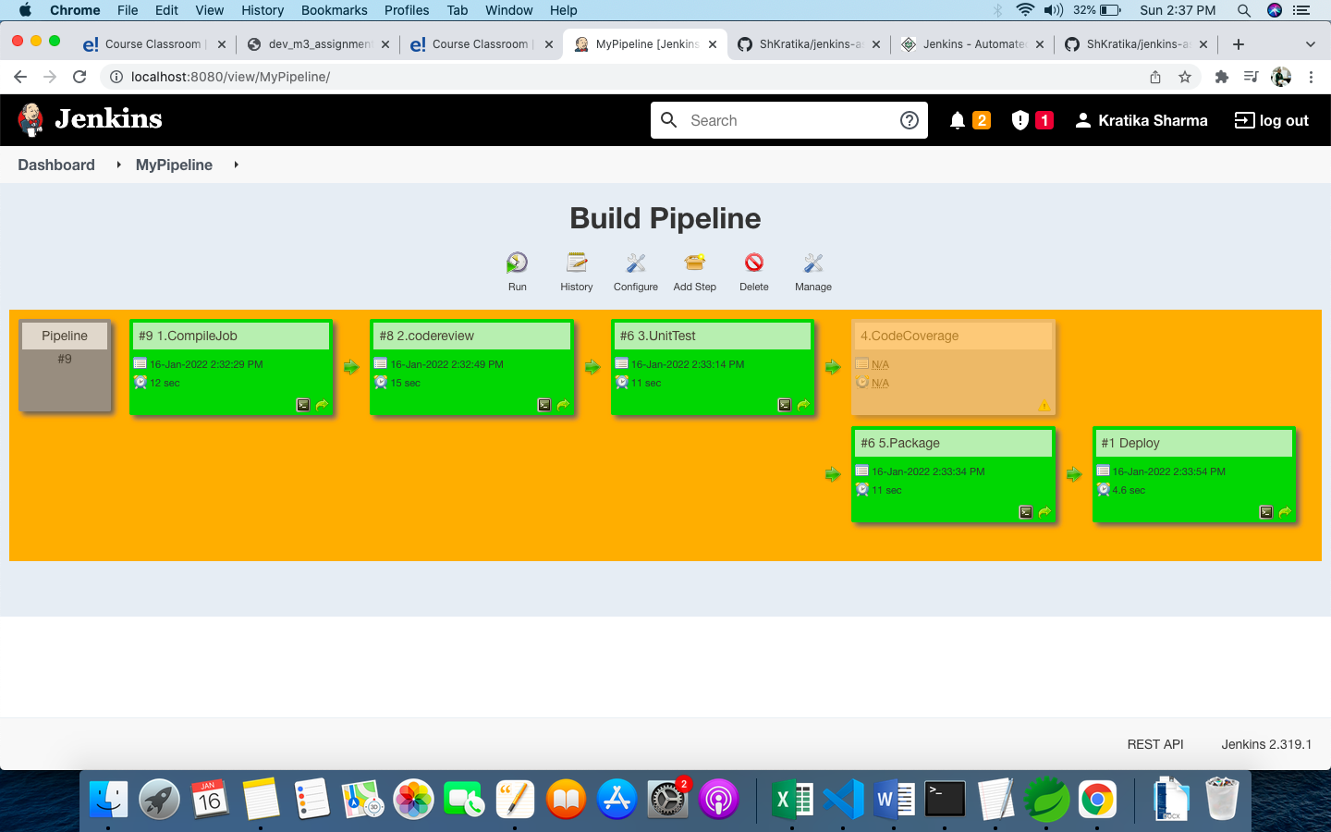

1. Jar file copied as per the Build Step :

